**The pipeline is created using AWS Code Pipeline. The pipeline pulls the code from GitHub, and deploys it to S3 whenever a change is detected in the code.**

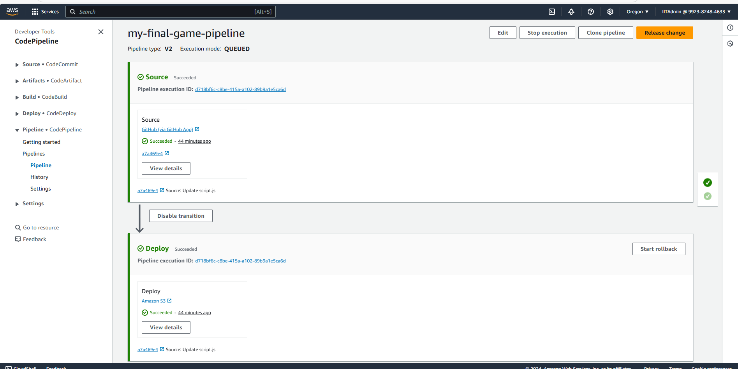

**My S3 Bucket. The code will be deployed and hosted in S3.**

